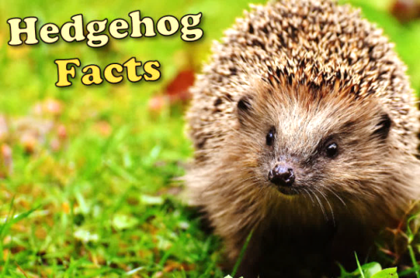
Help hedgehogs in
your neighbourhood
Overview:
Hedgehogs are declining in Britain. In fact, a third have been lost since the millennium. The cause of their decline is complicated and it seems likely that several different factors are at play. To ensure their survival, we need to make our gardens hedgehog friendly.

- What is happening to the number of hedgehogs in the UK?
______________________________________________________________________________

Log piles:
Log piles provide one of the best habitats for lots of wildlife, especially hedgehogs. They provide a safe, secure site for breeding or hibernating. They are also insect factories, providing a year round food supply for hedgehogs.

- What does ‘habitat’ mean (in this paragraph)?
______________________________________________________________________________

- Give two reasons why log piles make good homes for hedgehogs.
________________________________________________________________________________________________________________________________________________________________________________

___________ any old dead wood from your garden or ask the local park or wildlife reserve for _____________ to take some from their supply and pile it up in a quiet, _____________ corner of your garden. The bigger you can make it the ____________. As the wood _________ down, replace the logs from time to time.

permission | better | rots | Collect | undisturbed

Compost heaps:
Compost _________ can make an attractive nesting site for a _____________. Open air composting is also great for creepy ___________ (hedge hogs love to eat __________). Remember to be _____________ when turning compost heaps over with your fork.

crawlies | heaps | hedgehog | insects | careful
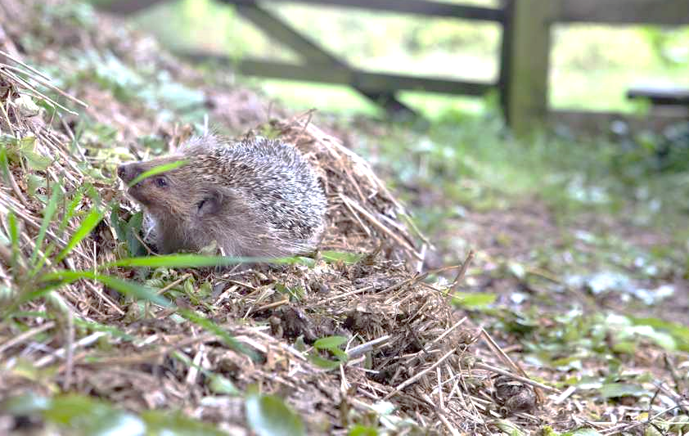

Leaf piles:
Not only can leaf piles be used as a potential nesting site but they can also be used for bedding material for any other nest sites or hedgehog boxes in the surrounding area. Please be careful when tidying leaf piles as there may be a hog in residence!

- Explain why do you need to be careful when you are moving a leaf pile?
___________________________________________________________________________________________________________________________
_________________________________________

Overgrown corner
Most gardeners have a big tidy once or twice a year, often in spring or at the end of the growing season. This can remove nesting or hibernation sites for hedgehogs, and reduces the amount of insects in the garden. Grasshoppers, for example, need standing vegetation in which to overwinter in. Pick a corner of your garden and leave it to go a bit mad – it can have native or non-native planting. The key is just to leave it untrimmed. You can do it!

- Give two reasons why having a ‘big tidy’ in your garden at the end of the growing season is a problem for hedgehogs.
____________________________________________________________________________________________________________________________________________________________________
_________________________________________

Ponds
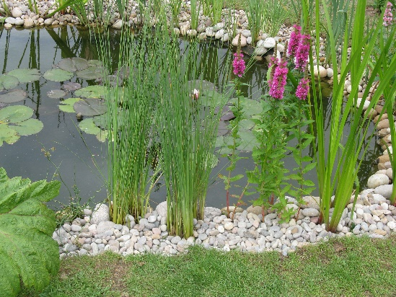
Not many people know that ponds are a great attraction for hedge hogs. Ponds allow them to benefit from a year-round water supply and hedgehogs will thrive on the added insects and amphibians that a pond will attract. Hedgehogs are tremendous swimmers, but make sure there is a gently sloping edge to help them make their way out of any pond to ensure they don’t drown.

6) Give two reasons why ponds are helpful to hedgehogs.
________________________________________________________________________________________________________________________________________________________________________________________

7) Are hedgehogs good or bad swimmers?
____________________________________________________________________________________________

8) If you have a pond what do you need to do to make sure hedgehogs are safe around them?

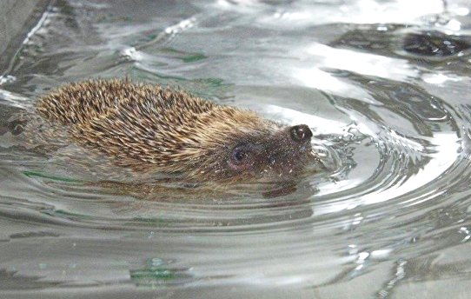
_____________________
_____________________
_____________________
_____________________
_____________________
_____________________
______________________________________________________________
Supplementary food for hedgehogs:
If you put out food for hedgehogs in the garden, they will eat it! The hedgehog’s natural diet mainly consists of slugs, ground beetles, caterpillars and worms. During cold or dry periods, these creepy-crawlies become much scarcer in gardens, so hedgehogs will benefit hugely from a shallow dish of water and extra food.

9) Why do hedgehogs sometimes benefit from having extra food put out for them?
_____________________________________________________________________________________________________________________________________________________________________________________________________________

What Should You Feed Hedgehogs?
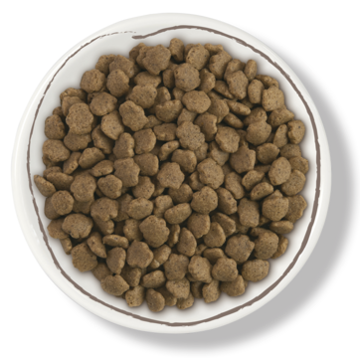
It’s important to remember that the food humans give to hedgehogs is additional to their natural diet, so please be sure to provide a nice mixture of food to get all the nutrients that they need. Place in a shallow dish and put in a sheltered area of your garden around sunset.
Specially made hedgehog foods now exist and can be bought from most local pet and garden stores.

Hedgehogs will also relish any combination of meat-based wet dog or cat foods as these are high in the protein that they need.

Hedgehogs are lactose intolerant so please do not give them milk. Bread is low in energy so fairly worthless to them.

10) What food is it safe to feed hedgehogs? What foods should you avoid giving hedgehogs? (Try to use the word however in your answer).
_____________________________________________________________________________________________________________________________________________________________________________________________________________
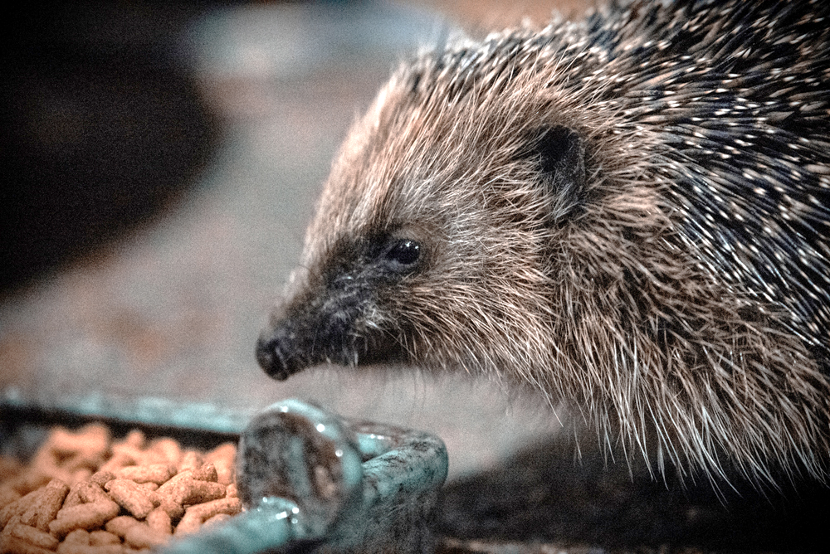
____________________________________________________________________________________________________________________________________________________________________

Here are some top tips for making your garden hedgehog friendly.

Task:
Design a poster encouraging people to make their garden hedgehog friendly. Include:
- Interesting images connected to hedgehogs
- Advice about where hedgehogs can live
- What they can eat
- How to keep them safe.
(You might want to include some of the tips above).

